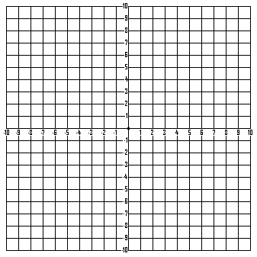
x | -3 | -2 | -1 | 0 | 1 | 2 | 3
y
EQUATION:
EQUATION:
EQUATION:
x | -3 | -2 | -1 | 0 | 1 | 2 | 3
y
x | -3 | -2 | -1 | 0 | 1 | 2 | 3
y

